Exploratory Data Analysis (EDA) and Data Visualization Documentation
This document outlines the key concepts and techniques for Exploratory Data Analysis (EDA) and Data Visualization, focusing on Univariate, Bivariate, and Multivariate analysis, along with various plot types for different data types.
1. Introduction to EDA and Data Visualization
Exploratory Data Analysis (EDA) is a crucial step in understanding data before building models or drawing conclusions. It involves summarizing data characteristics, identifying patterns, anomalies, and relationships. Data visualization plays a vital role in EDA by providing visual representations of data, making it easier to grasp complex information and communicate insights effectively.
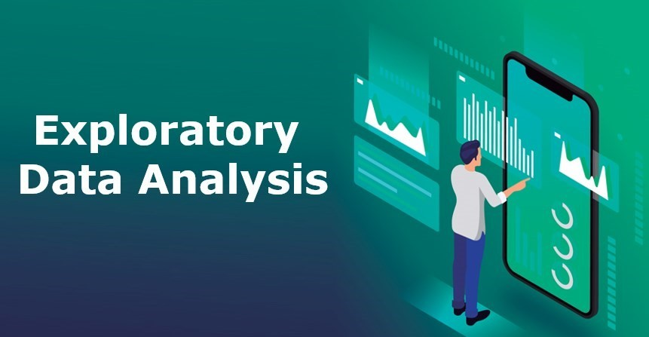
2. Univariate Analysis
Univariate analysis examines a single variable at a time. Its goal is to describe the distribution and characteristics of that variable.
- Continuous Variables:
  - Descriptive Statistics: Mean, median, mode, standard deviation, variance, range, percentiles (e.g., quartiles).
  - Visualizations:
    - Histograms: Show the distribution of the data, dividing it into bins.
    - Box Plots: Display the quartiles, median, and potential outliers.
    - Density Plots (Kernel Density Estimation): Provide a smooth estimate of the distribution.
    - Violin Plots: Combine box plots and kernel density plots.
- Discrete Variables:
  - Descriptive Statistics: Frequency counts, proportions, mode.
  - Visualizations:
    - Bar Charts: Show the frequency or proportion of each category.
    - Pie Charts: Illustrate the relative proportions of different categories (use sparingly).
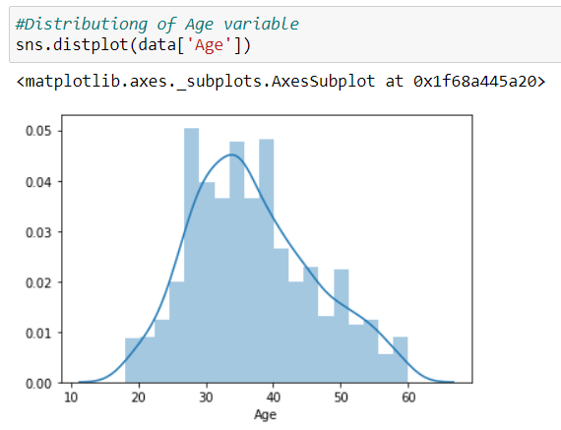

3. Bivariate Analysis
Bivariate analysis explores the relationship between two variables.
- Continuous vs. Continuous:
  - Descriptive Statistics: Correlation coefficient (Pearson, Spearman), covariance.
  - Visualizations:
    - Scatter Plots: Show the relationship between the two variables. Look for trends, clusters, and outliers.
    - Line Plots: Connect data points to show trends over a continuous variable (e.g., time).
    - Heatmaps: Display the correlation or relationship strength between two or more continuous variables using color gradients.
- Continuous vs. Discrete:
  - Descriptive Statistics: Compare summary statistics (mean, median) of the continuous variable across different categories of the discrete variable.
  - Visualizations:
    - Box Plots (grouped): Compare the distribution of the continuous variable for each category.
    - Violin Plots (grouped): Similar to grouped box plots, but with added density information.
    - Bar Charts (grouped): Show the mean or other statistic of the continuous variable for each category.

- Discrete vs. Discrete:
  - Descriptive Statistics: Contingency tables, chi-squared test.
  - Visualizations:
    - Stacked Bar Charts: Show the composition of each category of one variable within the categories of the other.
    - Grouped Bar Charts: Compare the frequencies or proportions of different combinations of categories.
    - Mosaic Plots: Visualize contingency tables, where the area of each rectangle is proportional to the cell frequency.
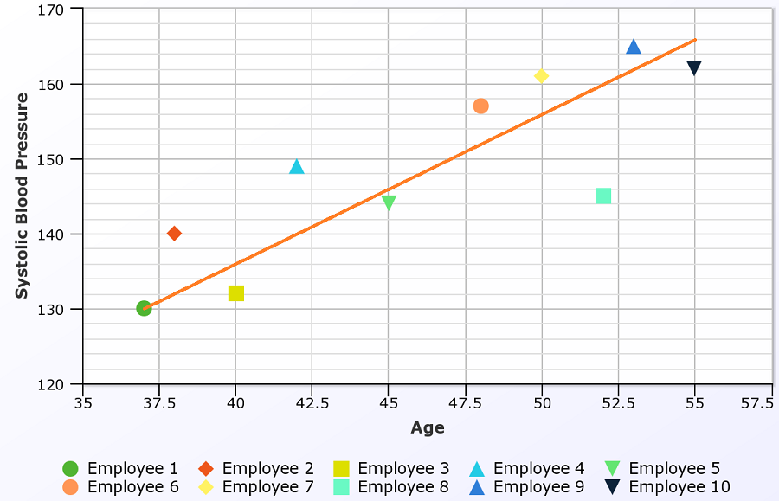
4. Multivariate Analysis
Multivariate analysis examines the relationships among three or more variables.
- Visualizations:
  - Scatter Plot Matrices: Show pairwise scatter plots for multiple variables.
  - 3D Scatter Plots: Visualize the relationship between three continuous variables.
  - Heatmaps (with hierarchical clustering): Useful for visualizing correlations or relationships between many variables.
  - Parallel Coordinate Plots: Display multiple variables on parallel axes, useful for comparing observations across variables.
  - Treemaps: Hierarchical data visualization, showing proportions and relationships.
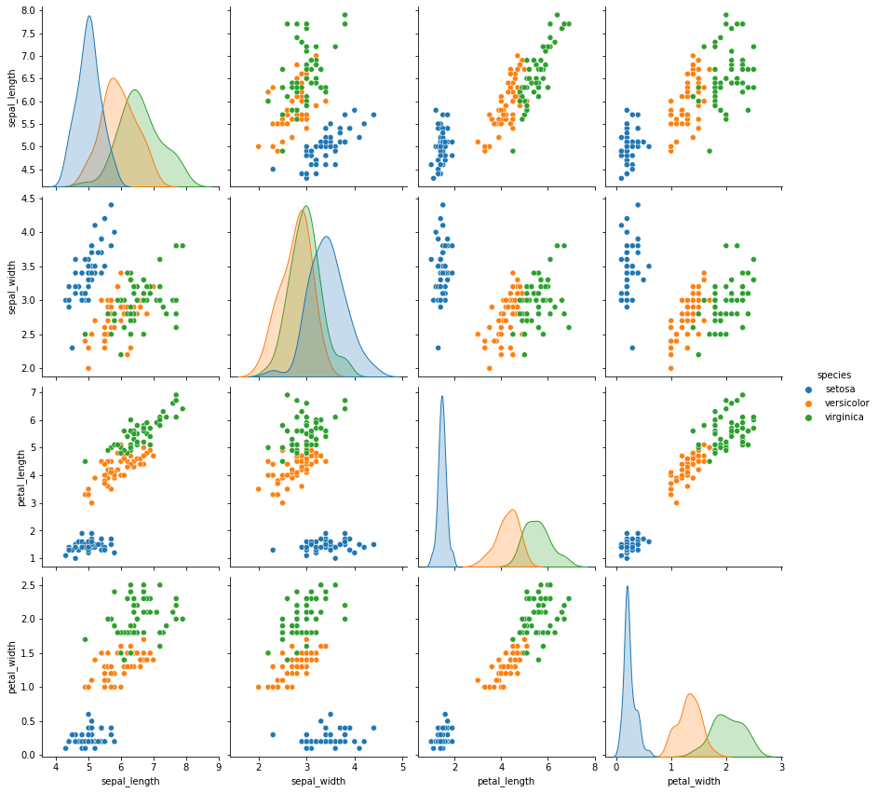
5. Plots for Different Data Types
- Numerical Data (Continuous & Discrete): Histograms, box plots, scatter plots, line plots, bar charts.
- Categorical Data (Nominal & Ordinal): Bar charts, pie charts, stacked bar charts, mosaic plots.
- Time Series Data: Line plots (connecting data points over time), area charts.
6.Plots for Time Series Variables
Time series variables are recorded over time intervals.
- Line Plot: Visualizes trends over time.
- Autocorrelation Plot: Shows how data points are correlated over time.
- Seasonal Decomposition Plot: Breaks down time series into trend, seasonality, and residuals.
- Heatmaps: Represent time-dependent patterns.

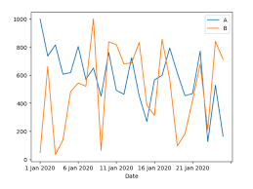
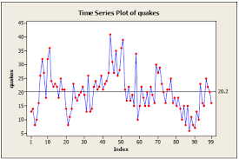

6. Plots for Specific Variable Types
- Continuous Variables: Histograms, box plots, density plots, violin plots, scatter plots (for bivariate analysis).
- Discrete Variables: Bar charts, pie charts.
- Time Series Variables: Line plots.
7.Interview questions related to EDA and Data Visualization?
General/Beginner Level:
- What is Exploratory Data Analysis (EDA)? Why is it important? (Focus: Understanding of the purpose of EDA)
- Describe the difference between univariate, bivariate, and multivariate analysis. (Focus: Basic understanding of analysis types)
- What are some common plots used for visualizing continuous data? Give examples and explain when you might use each. (Focus: Knowledge of basic plots and their applications - Histograms, Box Plots, Density Plots)
- What are some common plots used for visualizing categorical data? Give examples and explain when you might use each. (Focus: Knowledge of basic plots and their applications - Bar charts, Pie charts)
- Explain the difference between a histogram and a bar chart. (Focus: Understanding the nuances of plot types and their appropriate use)
- What is a box plot, and what information does it convey? (Focus: Ability to interpret box plots and understand key statistics like quartiles, median, outliers)
- What is a scatter plot, and what can you infer from it? (Focus: Understanding relationships between two continuous variables)
- What is the difference between a line plot and a scatter plot? When would you use each? (Focus: Understanding the specific use cases of these plots, especially with time series data)
Intermediate Level:
- Explain the concept of correlation. How do you visualize it? (Focus: Understanding correlation and its visualization with scatter plots and heatmaps)
- How would you handle missing data during EDA? (Focus: Practical considerations in data cleaning and preparation)
- How do you identify outliers in your data? What are some ways to handle them? (Focus: Understanding outlier detection techniques and strategies for handling them)
- You have a dataset with both numerical and categorical features. How would you approach exploring this data? (Focus: Applying appropriate techniques for different data types)
- Explain the difference between a heatmap and a correlation matrix. (Focus: Understanding the relationship between these two concepts)
- How would you visualize time series data and what patterns would you look for? (Focus: Specific techniques for time series visualization and analysis - Line plots, seasonality, trends)
Advanced Level:
- Discuss the challenges of visualizing high-dimensional data. What techniques can you use to address these challenges? (Focus: Knowledge of dimensionality reduction and visualization techniques like PCA, t-SNE, parallel coordinate plots)
- How can you use interactive visualizations to enhance EDA? (Focus: Understanding the benefits and techniques of interactive visualization)
- Explain the concept of data storytelling and how it relates to data visualization. (Focus: Ability to craft compelling narratives using data visualizations)
- How would you choose the most appropriate visualization technique for a given dataset and research question? (Focus: Deep understanding of visualization principles and their application)
- Design a data visualization strategy for a specific business problem (e.g., customer churn analysis). (Focus: Applying EDA and visualization skills to solve real-world problems)
- How do you evaluate the effectiveness of a data visualization? (Focus: Understanding principles of effective communication and user experience)
- Compare and contrast different data visualization libraries (e.g., Matplotlib vs. Seaborn vs. Plotly). (Focus: Deep understanding of the strengths and weaknesses of different tools)
7. Best Practices for Data Visualization
- Clear and Concise: Avoid clutter and focus on the key message.
- Informative Titles and Labels: Clearly explain what the plot represents.
- Appropriate Color Choices: Use colors effectively to highlight patterns and avoid misleading interpretations.
- Consistent Scales: Use consistent scales for axes to avoid distortions.
- Consider Your Audience: Tailor the visualizations to the understanding of the intended audience.
8. Tools for Data Visualization
- Python: Matplotlib, Seaborn, Plotly
- R: ggplot2
- Tableau
- Power BI
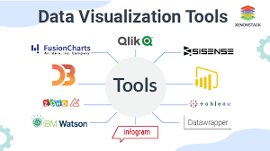

9) Conclusion
EDA and data visualization are crucial steps in data analysis. Choosing appropriate plots based on variable types helps in better interpretation and decision-making. Proper visualization aids in uncovering hidden patterns and guiding further analysis.
